**Calculator Assumed**

**Probability Laws**

Time: 45 minutes

Total Marks: 45

Your Score: / 45



**Question One: [2, 1, 1, 2, 1 = 7 marks]**

The probabilities of two events, A and B, are such that  and .

Determine:

1. the minimum value of.
2. by considering your answer to part (a), what you can say about events A and B when is a minimum.
3. , using your answer from part (a).
4. the maximum value of .
5. by considering your answer to part (d), what you can say about events A and B when is a maximum.

**Question Two: [1, 1, 2, 2 =6 marks]**

The probabilities of two events A and B are such that and .

Determine:

1. if the events A and B are independent.
2. if the events A and B are independent and 
3. if .
4. The range of possible values of if .

**Question Three: [3 marks]**

Maddie has rolled a fair six-sided dice 10 times with the following results:

3 5 6 6 2 6 1 6 6 2

Maddie looks at her results and hypothesizes that the chance of her rolling a 6 next is 0.5.

Explain with mathematical reasoning, the validity of her hypothesis.

**Question Four: [3 marks]**

The probability of two events A and B are such that  and 

If events A and B are independent, determine .

**Question Five: [2, 3 = 5 marks]**

Given that  and , calculate given that A and B are:

1. mutually exclusive.
2. independent.

**Question Six: [3 marks]**

If it’s raining when Matt wakes up, he drives to work instead of catching the bus. The chance of rain tomorrow is 0.95. If it doesn’t rain, there is equal chance he will either drives of takes the bus.

What is the probability Matt will drive to work tomorrow?

**Question Seven: [1, 2, 4 = 7 marks]**

A piece of machinery is comprised of 4 components, each of which work independently of the other three components.

The first component and second component each have a 5% probability of failure.

The third component has a 2% probability of failure and the final component has a 1% chance of failure.

The machine won’t work if all the components fail.

Calculate the probability that:

1. only the second component fails.
2. the machine stops working.
3. at most one of the components fail.

**Question Eight: [3, 3, 3 = 9 marks]**

The goalkeeper in a netball team has a 3 in 10 chance of shooting a goal.

Determine the probability of:

1. in 8 shots for goal, every second one is successful.
2. in two shots for goal, at least one is successful.
3. in 20 shots for goal, three consecutive shots are successful.

**SOLUTIONS**

**Calculator Assumed**

**Probability Laws**

Time: 45 minutes

Total Marks: 45

Your Score: / 45



**Question One: [2, 1, 1, 2, 1 = 7 marks]**

The probabilities of two events, A and B, are such that  and .

Determine:

1. the minimum value of.



0, where 

1. by considering your answer to part (a), what you can say about events A and B when is a minimum.



Events A and B are mutually exclusive

1. , using your answer from part (a).



0.15

1. the maximum value of .

0.3

1. by considering your answer to part (d), what you can say about events A and B when is a maximum.



, B is a subset of C

**Question Two: [1, 1, 2, 2 =6 marks]**

The probabilities of two events A and B are such that and .

Determine:

1. if the events A and B are independent.



1. if the events A and B are independent and 



1. if .



1. The range of possible values of if .



**Question Three: [3 marks]**

Maddie has rolled a fair six-sided dice 10 times with the following results:

3 5 6 6 2 6 1 6 6 2

Maddie looks at her results and hypothesizes that the chance of her rolling a 6 next is 0.5.

Explain with mathematical reasoning, the validity of her hypothesis.

Maddie’s hypothesis is incorrect since each roll of the dice is independent of the last.



**Question Four: [3 marks]**

The probability of two events A and B are such that  and 

If events A and B are independent, determine .



**Question Five: [2, 3 = 5 marks]**

Given that  and , calculate given that A and B are:

1. mutually exclusive.

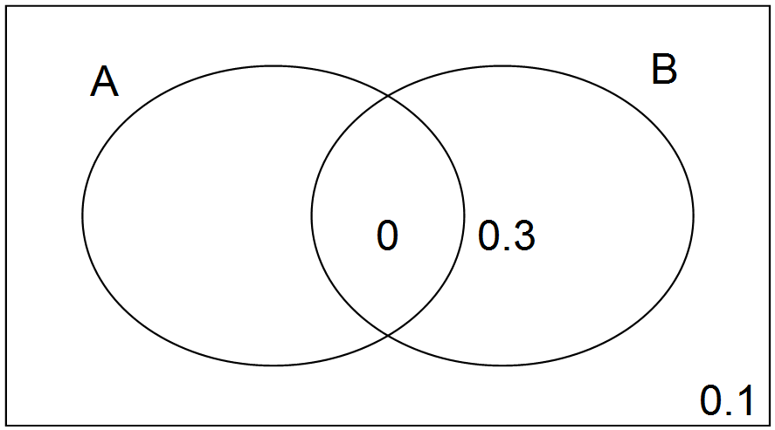

0.1



1. independent.





**Question Six: [3 marks]**

If it’s raining when Matt wakes up, he drives to work instead of catching the bus. The chance of rain tomorrow is 0.95. If it doesn’t rain, there is equal chance he will either drives of takes the bus.

What is the probability Matt will drive to work tomorrow?

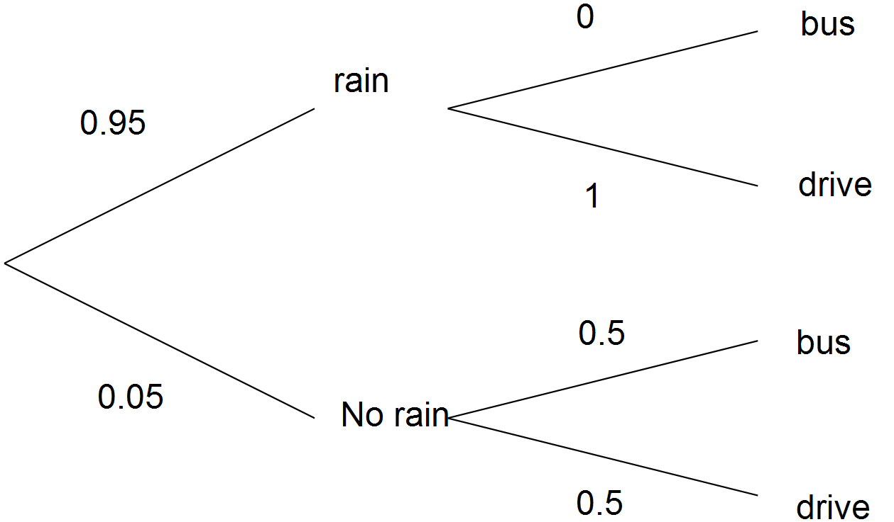



**Question Seven: [1, 2, 4 = 7 marks]**

A piece of machinery is comprised of 4 components, each of which work independently of the other three components.

The first component and second component each have a 5% probability of failure.

The third component has a 2% probability of failure and the final component has a 1% chance of failure.

The machine won’t work if all the components fail.

Calculate the probability that:

1. only the second component fails.





1. the machine stops working.





1. at most one of the components fail.



**Question Eight: [3, 3, 3 = 9 marks]**

The goalkeeper in a netball team has a 3 in 10 chance of shooting a goal.

Determine the probability of:

1. in 8 shots for goal, every second one is successful.





1. in two shots for goal, at least one is successful.







1. in 20 shots for goal, three consecutive shots are successful.





